While she sleeps webstore

NEA Project

4205

Richard Burney

Contents

Test Strategy 2

Analysis Stage Headings 5

Design 6

Evaluation 7

# Test Strategy

My website and store will need to be tested thoughly before it can be released to the public. This is to make sure that all users can a pleasant and easy explirence on the site. When testing, I will be looking for errors within my code and also the layout of the website. When found, the errors will be corrected. In my testing I will be checking for major and minor errors, but also the user experience. I will be using the following method for my testing:

I will start at the homepage as this is the first page that anyone will see if they enter the site. I will check that each of the links work on this page and that the page still flush on the user’s screen.

From here, I will go to the login/register page and show that a user can be created and then the user can login and logout easily. I will also show that a user cannot be logged in if the password is incorrect and that another account cannot be created with the same username or email. Registering an account can be used to save the user’s address, orders and set up email notifications of shows in their area. So the page must be easily read and edited as it is the most used part of the website. When logged in, the user can access their profile from the same place to login link was. From here the user can see all the data stored of them, see their orders. Edit their account, delete their account and log out. I will show that all of these functions work and that there are measures to stop accidental edits or deletion, by being password protected. Also, if the logged in user is of admin or owner status, then the admin tools page link will show up in the profile. Only a user will an access level of 2 or 3 can enter this page. I will prove that a non-admin cannot enter this or the owner page by trying to access it with a user with access level of 1, 2 and 3 and show what the differences are. On the admin section, an admin can see all the stock with the profit that that each item brings in, with the total profit of the website. They can view all shows, add a new show or edit an existing one. They can add stock to one item or add an entirely new item to store and finally they can view all the orders from all users and edit the status of them (dispatched and delivered). I will show all this working on test data that will be created through the testing of the other parts of the website such as ordering items from the store. In the user is of access level 3, when they enter the admin tools page, they will also see the owner tools sections, here they can change the access level of each user to 1, 2 or 3. After this I will show how the shows that have already passed will be automatically deleted from the database. Even if the date is edited. And, how the user can set up email notifications for a specific location and if there is a show there, they will get an email.

Next, I will show the store and all the items in it. How each item has their own induvial page, where it shows pictures, price and how much stock each size has. From here you can select what size and the quantity of item that the user wants to put into their cart. Then I will access my cart by clicking the cart icon on the navbar. This page shows all of the items in the specific user’s cart, the amount of each item and the total price of all the items. I will show how items can be removed or quantity lowered easily, by pressing the “remove” button. From here I will continue onto the confirming order page. The next page is the address confirmation, where the address entered on the profile will be brought forward but if it is not correct then there is a link to change it. After this, the next page is the payment page, where I will put some a card number, date and CVV, this is test data and money will not be taken. After this page is the order confirmation page, this is where the users’ cart, address and card will be shown so the user can make sure that it is correct. When the order is placed, I will show how the order has been added to the “Your Orders” page on the profile and how an email has been sent to the specific email that the user set in their account creation. After this, I will show how different users can only see their own orders and cart. This is to make sure that users do not get other users orders on their page and don’t get confused by it.

After this, I will logout of this account and login to an owner account. From here, I will show that when you are an admin or a owner, there is now a new link to the admin tools in the profile. I will then go to the admin page but straight after logout of my account and back into the test account. I will then show that even if a user knows the url, if they do not have the access level, then they can not enter the admin or owner page and it will just return a 404 error. Now I will log back into the admin account and back into the “admin tools” page. On the main admin page, it shows the entire stock and how much profit each item makes. There is also a pie chart that shows the website’s costs and profits. There is also an additional navbar for the admin tools section, and if the user has an access level of 3, will also get the owner tools here. I will then show this difference by showing that the logged in account (“Richard”) has an access level of 3, and then I will log into an admin account and when I go onto the admin tools, the “owner tools” section will not be there. In the “Stock” section of the admin tools, it shows the user all the stock and the information on the items, for example the amount bought and price. From this page, I will show that an admin can top up the stock of a specific item and add a new item to the store entirely. After this is will show the orders page, this page shows all of the orders of all of the users. Its also shows the status of their order, however if the status of the order is delivered, the order is not shown in the table. Also, from this page, I will show that an admin can change the status of an order, when it is needed, this would be when the order has been dispatched and confirmed as delivered. When an order status is changed, the users who created the order will receive an email of the status change pf their order, I will show this happening for both “dispatched” and “delivered”. The final part of the admin page is the shows tools. This is where the admin can see all the upcoming shows. They can also create and edit the show easily. I will show the creation and editing of a show and in doing so I will created one that has a date that already past, this is because when someone enter the “shows” page, the website works out the current date and compares it to the date of the show and if the show has a date that has already been , it will delete that show from the database, so it will not be displayed.

Next, I will show the owner tools page, here the owner (someone of access level of 3), can see all the users on the database, along with their full name and their email. Here an owner can change the access level of a specific user to either 1 (regular user), 2 (admin) or 3 (owner). And I can show how changing this leads users to be able to access the admin and owner tools.

I will show this by logging back out of the owner account and back into the test account. Now on the profile page, there will be the admin tools button. But when I go into it, the owner tools section is missing, this is because to access owner tools an access level of 3 is needed, which this account doesn’t have.

After I have shown this, I will show how an order status can be changed by selecting the order id and changing the status to “Dispatched”. When this happens, the website also sends an email to the user telling them that their order has been dispatched. I will show this happening by using a test account on gmail. The same also applies to when an order is changed to “Delivered”, however this order now disappears from the orders table, this is because the “delivered” orders are all filtered out, so it does not clutter up the page. Next, I will show the stock page, this page shows all the stock and necessary information on it. From this page and admin is able to add stock to an existing item or create a new item entirely. I will show both working.

Following this, I will show how the show email notifications work. So, a user will go to the “shows” page and then from here press the link to “Set Up Email Notification”. From here the user types in the location for which they would like to receive emails for. The email used is pulled directly from the User Database. Now when I go back into the admin tools page and the shows section when I created a show or edit an existing one, It scan the email notifications database and if there is a match, it will send and email to the user, with the location in the email, in case they have set up multiple email notifications.

Finally, I will show how other others are not able to access any data on any other user. I will show this by showing that a user can only ever access their own profile, even if they type in other users’ url. Also, I will show how the different users’ cart stay different, so peoples saved items don’t cross into other users’ cart. Also, during this I will show that a user’s cart is saved so even if they don’t enter the site for a year, along as the item still exists, it will still be in their cart.

Testing video: <https://youtu.be/DLxIps2yyZY>

# Analysis Stage Headings

* The Problem Definition

A website is a series of pages linked together for the ease of use for the user. A website has become the best way of marketing, sharing information, shopping and much, much more. A website can be the single, most important tool for a band, as it is a way to get their music out there, list the concerts they are playing and allow their fans to buy their merchandise.

A bad website can lead to fans being misinformed or even losing their orders. This emphasis on websites, will only increase as the world becomes even more digital; to be successful without a website is now harder than ever. The ease of having a website to the end user is astronomical, being able to access it anywhere, on any device, every day of the year.

Background research

* + into other systems/games and the features they offer)
  + Most dedicated band websites have a few similar parts to their websites;
  + Tours, store, a page about their music and and page about themselves.
  + Also, some of these bands have different store for different parts of the world, ie. Us and eu
* Description of Current System
  + if a business system:
  + There are many websites with a store selling ‘While She Sleeps’ merchandise, including their official website. But the information of the band can only be found on Wikipidea, which can be edited by anyone so it is not completely reliable. In all of these stroes, it is difficult to tell what is official and what is not. So the profits of the merchandise would not go to the band but a third party company that has no relation to the band.
* Identification of End Users/Players
  + These would be fans of the band which would like to attend a show or buy merchandise
* Objectives
  + Have a functioning profile system that can be updated by the user
  + Have a store that can be used by the user to buy merchandise
  + Have the store pull the address from the users profile but check whether it is right
  + Have a most popular page on the store that is automatically updated with the items that have been bought the most
  + Have automated emails sent out when an order is out for delivery
  + Have charts to show what is the most profitable items
  + Have an easily updatable shows page that takes off a show when it has been finished automatically
  + Have email notifications for shows, so that if a show happens in a certain area a user can be notified
  + Have a secure admin page when a user can update order status, add a show, edit a show, top up stock for an existing item or add a whole new item to the store
  + Have a secure owner page where a user can change the access level of all the other users
* Modelling (examples include):
  + Data Flow Diagrams
  + Entity Relationship Diagrams
  + Flow Charts
  + Manual proof of complex algorithms
  + Prototype of some areas of your code.

# Design

User Interface

I have chosen to have a graphical interface for my website instead of a command-line interface as a command-line interface would not fit a website environment. On my website my main source of navigation will be a navigation bar at the yop of the page which leads to the main pages of the website, such as the store, music and a profile page. I will also make it easy for users/admins to change aspects of what the website remembers ie. User data of Store item data. There is also a separate navigation bar for the store that have links to store specific pages such as mens/womens, but also has a link back to the main page of the website where all other aspects of the website can be accessed. In the admin tools section, which is accessible from the profile to applicable users, there is a secondary navbar which shows all of the sections of the admin tools. I thought this was necessary so it is easy to navigate for the user.

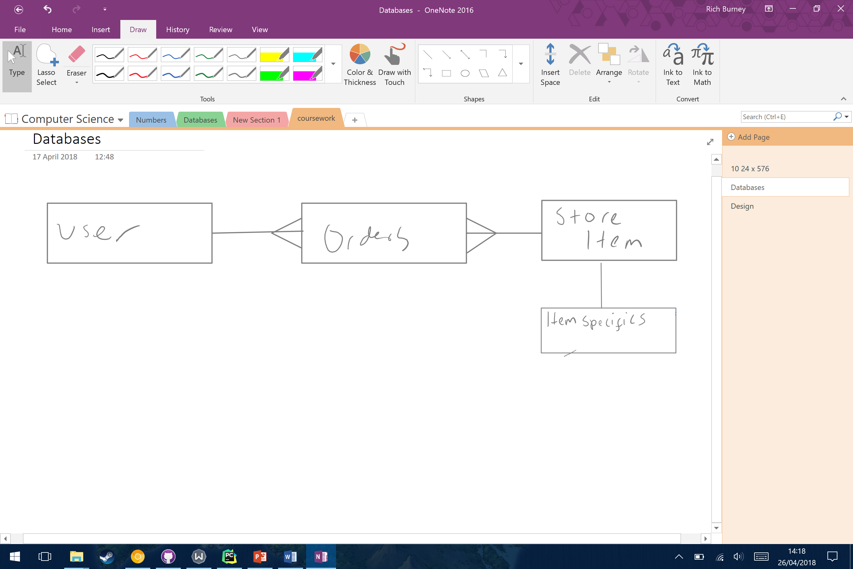

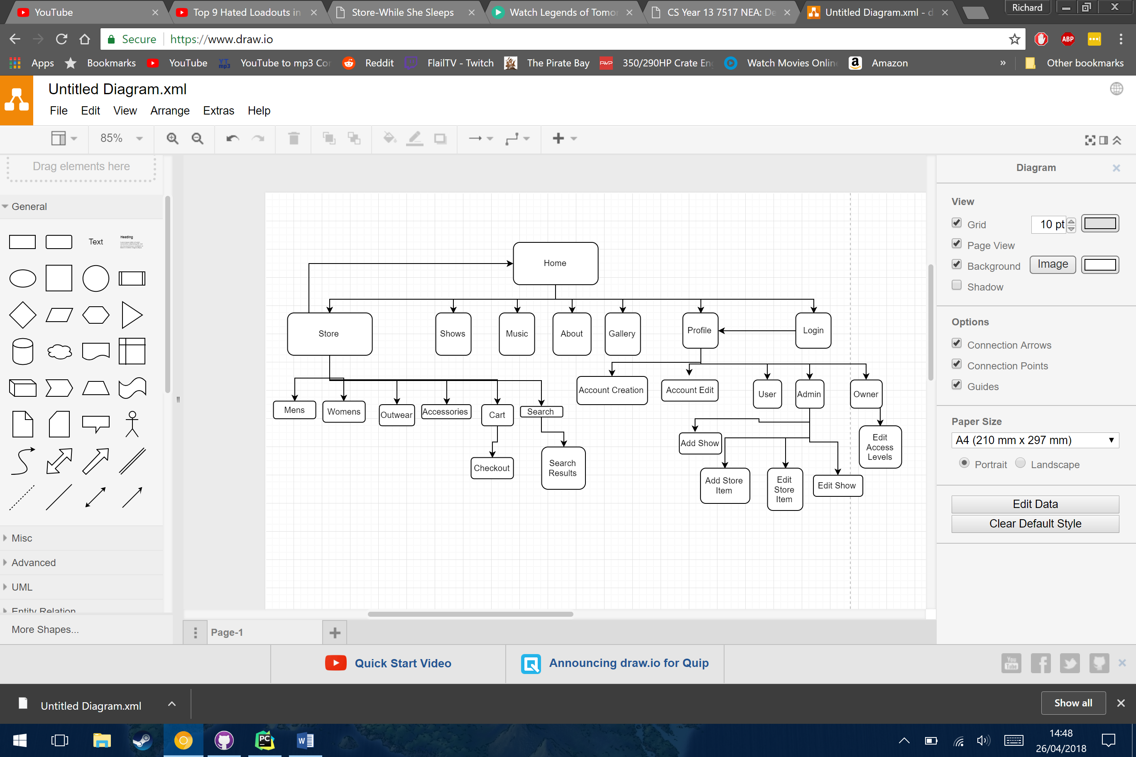

# 

# Evaluation